BCSE302L- Database Systems
Register Number | 24BCE1731 | Subject Code | BCSE302L
Name of the Student | Abhinav Bhuniya | Subject Name | Database Systems
Programme | BTech CSE | DA-1
Date | 23/01/2026

School: SCOPE
Project Title: Inventory & Supplier Management System
Course Code: BCSE302L
Course Title: Database Management Systems
Class Number: CH2025260501233
Semester: Winter 2025-26
Slot: A1+TA1
Team members: Abhinav Bhuniya, 24BCE1731
Aveek Sanyal, 24BCE1081
Gaurav Satyedev, 24BCE1828
Course Faculty: Dr. L.M. Jenila Livingston

1.Abstract
Managing inventory manually leads to problems such as:
- Inaccurate stock records
- Difficulty in tracking suppliers
- Poor management of purchase orders
- Delay in payment tracking
A database-driven system is required to efficiently manage inventory and supplier information.

2.Modules
Product Management Module
Supplier Management Module
Inventory Management Module
Purchase Order Management Module
Payment Management Module

3.ER diagram
Entities:
- Product
- Supplier
- Purchase_Order
- Stock
- Payment
Relationships:
- Supplier supplies Product (Many-to-Many)
- Purchase_Order resolves the M:N relationship
- Stock depends on Product
- Payment is linked to Purchase_Order

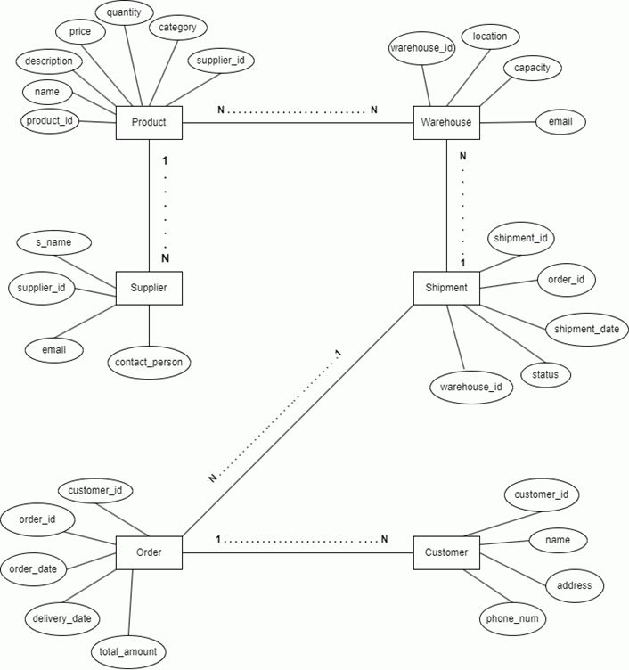

4.ER Mapping with schema diagram
